**eTool Technical Documentation**

Contract: PAC/20181120/02

Contractor: Travis Sondgerath MS, MPH

Contents

Getting to the Tool 3

Key Performance Indicators and Summary Measures 3

Data for Equipment Information Form 3

Data for Equipment Activity Form 4

Equipment ID for Requests 4

# Getting to the Tool

The [eTool](https://travis-shinin-spot.shinyapps.io/ona_reporting_app/) can only be accessed with internet connection. While the eTool displays data on current and historical trends, detailed information is also provided to assist in looking up the current or historical status of a specific piece of equipment or pending request for equipment care. Additionally, the eTool can be used to look up information to fill in forms hosted on Ona.

# Key Performance Indicators and Summary Measures

Fill in later

# Data for Equipment Information Form

Go to the Equipment Details tab.

Using the eTool to Fill out the Form

If you are updating information for an existing piece of equipment, the Equipment Information Form can be used to alter that data. However, for equipment characteristics that you do NOT wish to change for that piece of equipment we suggest you look up the information necessary to fill out the entire form in the eTool. If you only plan to enter recent maintenance or calibration activities, use the Equipment Activity Form instead (described in the next section). Use the tables in the Equipment Details and Equipment Activity details tabs (shown below).

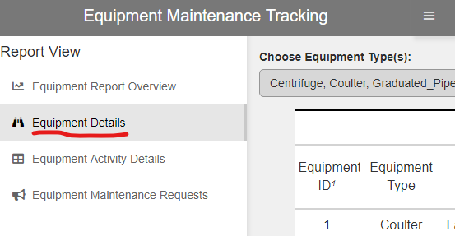

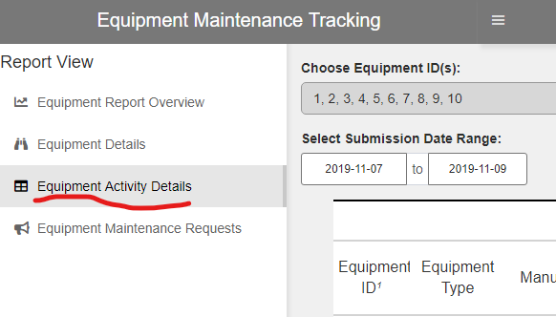

To locate specific piece(s) of equipment in either the Equipment Details or Activity Details tables use the equipment ID filter at the top left of the screen.

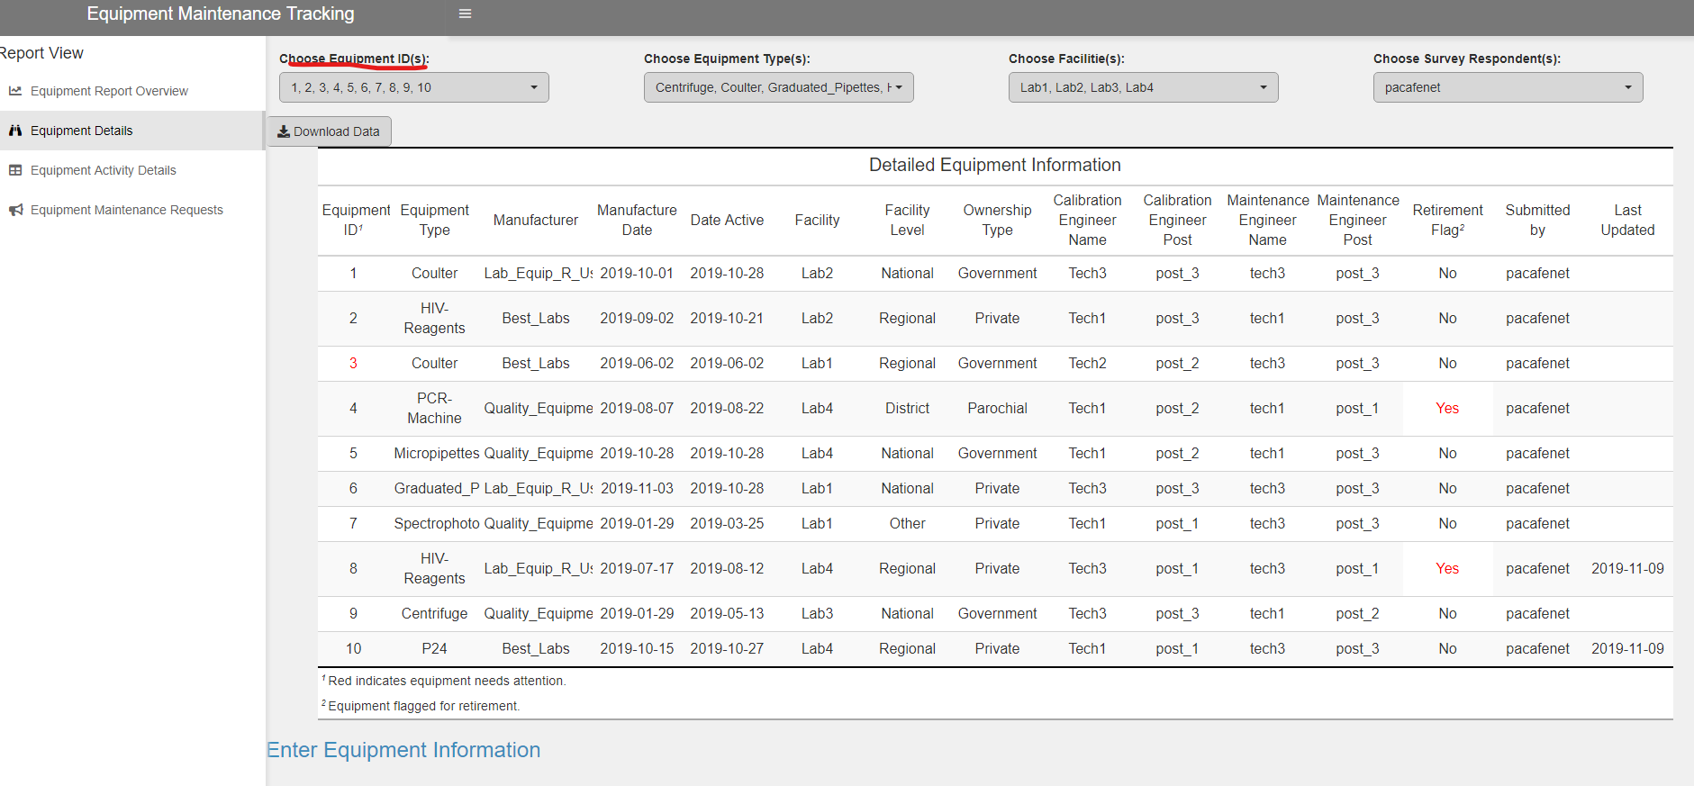

# Data for Equipment Activity Form

Dd

# Equipment ID for Requests

Dd